AE 4361 – Assignment 5

1) a)

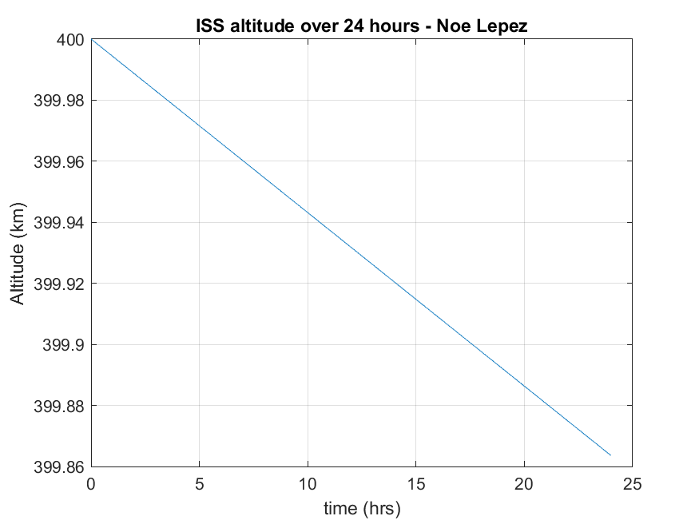

b) The delta v required after 24 hours is **0.0773 m/s**.

c) $m_{prop}=m_{0}\left[1-\exp\left(\frac{-f_{D}Δt}{g_{0}I_{sp}}\right)\right]=(2.5×{10}^{5}+7150)\left[1-\exp\left(\frac{-\left(0.0773\right)×86400}{9.81 × 302}\right)\right]$

=**6.7104kg**

*Workspace outputs for Q1 matlab code:*

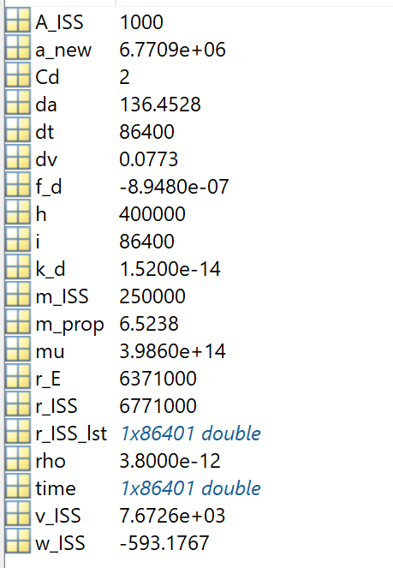

2) a)

|  |  |
| --- | --- |
| **Satellite name** | **Position (km)** |
| QZS-1 | x= -24,371.056 |
| y= 32,026.357 |
| z= 8,027.077 |
| QZS-2 | x= -24,905.318 |
| y= 22,853.526 |
| z= 30,095.105 |
| QZS-3 | x= -25,383.052 |
| y= 33,662.647 |
| z= 36.793 |
| QZS-4 | x= -34,500.873 |
| y= 20,615.646 |
| z= -7,899.728 |

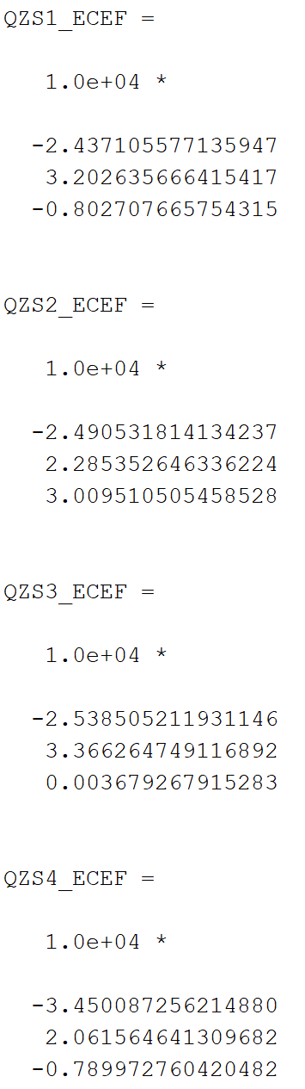

b)

|  |  |
| --- | --- |
| **Pseudorange number** | **Pseudorange (km)** |
| ρ1 | 41,037.420 |
| ρ2 | 45,257.786 |
| ρ3 | 42,161.310 |
| ρ4 | 40,959.990 |

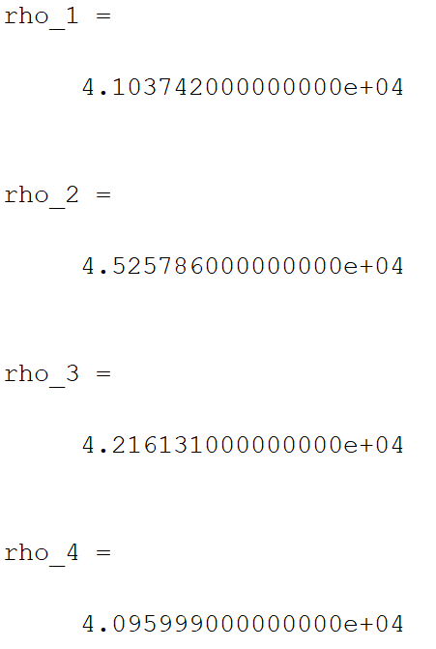

3) a)

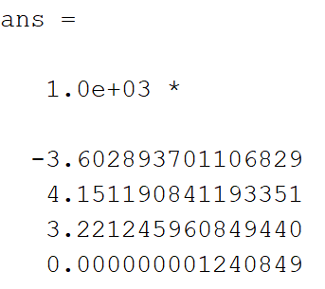

**xu = -3,602.8937 km**

**yu = 4,151.1908 km**

**zu = 3,221.2460 km**

**tu = 1.2408491*10-06 s**

latitude of 30.3719

longitude of 130.9553

This is the JAXA Tanegashima space center!